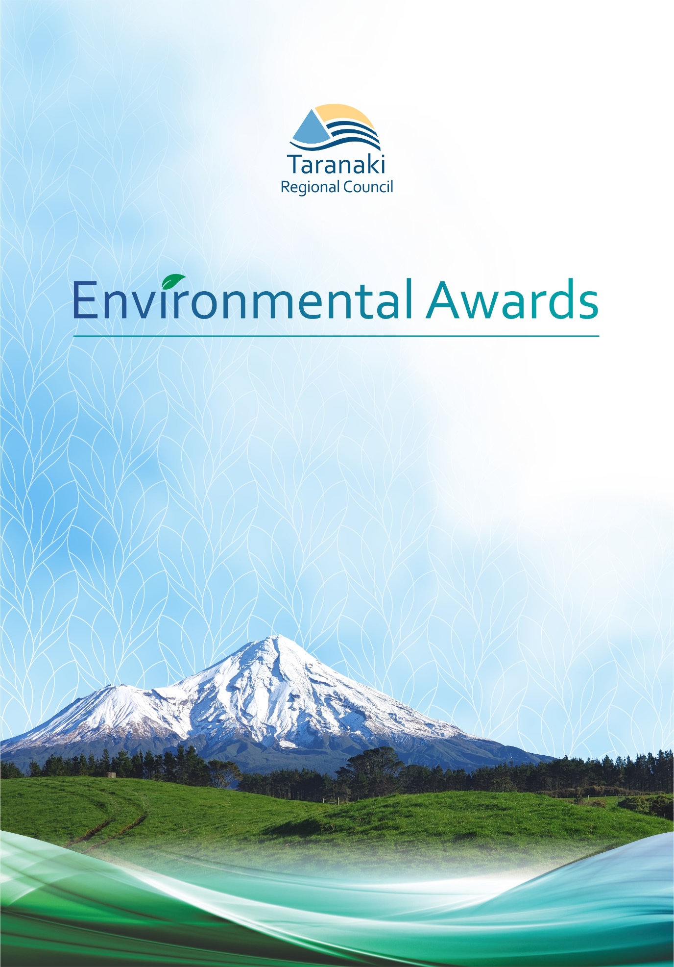

NOMINATION FORM
The Taranaki Regional Council Environmental Awards recognise outstanding initiatives in our region to protect and enhance Taranaki’s high-quality environment.
The awards encourage environmental stewardship and sustainable development of our natural resources.
Who can make a nomination?
The Awards are open to individuals, organisations, businesses and communities who are contributing to our environment. You can nominate yourself, your organisation, business, school, community group, iwi, hapu or whanau, or you can nominate someone else.
Important dates
Nominations open on Monday, 19 July and close at 5pm on Friday, 20 August.
Submit your application
Submit your application by email to awards@trc.govt.nz or complete the online nomination form: www.trc.govt.nz/environment/working-together/environmental-awards/

ELIGIBILITY CRITERIA
- Activity or project must be carried out in the Taranaki region.
- Where applicable, have 100% resource consent compliance throughout the period of activity, or for a minimum of about five years.
- Activity or project must be current, ongoing or near completion.
- Previous winners are eligible for nomination after a minimum of five years.
- Recipients of other awards are eligible for nomination for these awards.

ASSESSMENT CRITERIA
Degree to which a practical contribution to the sustainable management of Taranaki’s natural resources has been made.
Demonstrated success of the project in terms of mitigating potential environmental impacts and/or environmental protection efforts, including the significance and magnitude of such efforts.
The extent to which the project or individual has increased understanding of, or bought about change on, environmental issues.
Demonstrated innovation or collaboration.

NOMINEE DETAILS
Name of person (if applicable): | Click or tap here to enter name of nominee.
Name of organisation (if applicable): | Click or tap here to enter organisation.
Postal address: Street name / PO Box:  Town:  Postcode: | Click or tap here to enter Street name/PO Box.  Click or tap here to enter Town.  Click or tap here to enter Postcode.
Phone number: | Click or tap here to enter Phone number.
Email: | Click or tap here to enter Email.

NOMINATOR DETAILS
Name of person completing application (if applicable): | Click or tap here to enter name of nominator.
Name of group or organisation: | Click or tap here to enter organisation.
Position within group or organisation: | Click or tap here to enter position within group.
Postal address: Street name / PO Box:  Town:  Postcode: | Click or tap here to enter Street name/PO Box.  Click or tap here to enter Town.  Click or tap here to enter Postcode.
Phone number: | Click or tap here to enter Phone number.
Email: | Click or tap here to enter Email.

CATEGORY
Please select a category. Tick one box only.
Environmental leadership in business | Recognises businesses or local authorities, or their projects or individual staff that demonstrate kaitiakitanga, innovation or efficiency, an ongoing commitment to environmental best practice or continually high environmental performance. | ☐
Environmental leadership in dairy farming | Recognises farmers who are committed to environmental stewardship and sustainable farming practices, in all aspects of their dairy farming activity. | ☐
Environmental leadership in land management | Recognises land users who are committed to environmental stewardship and sustainability in their meat, fibre, forestry or other land use operations. | ☐
Environmental action in the community | Recognises not-for-profit organisations, groups, individuals, iwi, hapū or whānau that are taking action to protect or enhance the environment, or are increasing understanding of environmental issues. | ☐
Environmental action in education | Recognises actions in the education sector to protect or enhance the environment, or commitment to increasing understanding and bringing about change on environmental issues. | ☐

NOMINATION DETAILS

SUMMARY
Provide a concise description of the project or individual and the main reasons the nominee should be selected for an award. (ie What has the project achieved and what makes it outstanding?) (200 words max)

PRACTICAL CONTRIBUTION TO SUSTAINABLE MANAGEMENT OF NATURAL RESOURCES

Explain the negative environmental impacts that the initiative is addressing (if any). Tick all that apply. If additional space is required, please attach additional information.
LAND
☐ | Erosion
☐ | Loss of native plants, animals or ecosystems that are under threat
☐ | Connectivity of habitat and ecosystems
☐ | Degradation of soil health
☐ | Invasive plant species
☐ | Invasive animal species
☐ | Loss of biodiversity
FRESHWATER
☐ | Sedimentation
☐ | Nutrient pollution in waterways
☐ | Wetland loss
☐ | Native fish habitat or species loss
☐ | Groundwater degradation
MARINE
☐ | Climate change – acidification, temperature
☐ | Management of waste
☐ | Coastal pollution
AIR
☐ | Air pollution
OTHER
☐ | Waste minimisation
☐ | Energy wastage
☐ | Other (please specify)
☐ | Other (please specify)
☐ | Other (please specify)
☐ | Other (please specify)

Provide a summary of the noteworthy actions that the nominee has taken which contribute to the sustainable management of Taranaki’s natural resources and address any issues identified in section 1.1 (bullet points are fine).

DEMONSTRATED SUCCESS OF ENVIRONMENTAL PROTECTION EFFORTS
Describe in detail the visible or measurable environmental improvement or outcomes from the activity. (Discuss in terms of the negative environmental impacts identified in 1.2) Also note any points – such as threatened species protection, safeguarding important ecosystems – that demonstrate the significance or magnitude of the project.

INCREASED UNDERSTANDING OF ENVIRONMENTAL ISSUES
Does the nomination raise awareness or educate others about environmental issues? Does it aim to bring about change in behaviour among other individuals or groups? Please explain.

COLLABORATION AND INNOVATION
Describe any innovative or collaborative aspects of the activity. How has the nominee involved or interacted with the community (if applicable)? What, if any, innovative tools or techniques have been applied?

ABOUT THE NOMINEE
Provide any additional information about the nominee. Eg background about the business or farm size, details about the individual if a person is nominated (100 words max).

SUPPORTING INFORMATION
Attach any additional information – photographs, maps, endorsements or testimonials, media etc – to support the nomination.
Attachment 1:
Attachment 2:
Attachment 3:
Attachment 4:

